WAYNE CENTRAL SCHOOL DISTRICT
BOARD OF EDUCATION MEETING AGENDA


DATE: September 11, 2002
TIME: 7:00 p.m.
PLACE: District Office Board Room

7:00 Call to Order /Pledge of Allegiance
7:00 Executive Session
7:30 Moment of Silence for September 11 Tragedy
7:32 Approval of Agenda/Approval of Minutes Att. 1

7:35 Public Comment
7:40 Board Member Comments
7:45 Board President’s Comments

7:50 Action Item Report

7:55 Superintendent’s Report
- Opening Day Report
- G.A.P.P. Program – Mrs. Straub Att. 2
- Capital Project Update
- Student Questions

8:20 Items for Board Action:
- Personnel Action Att. 3
- CSE/CPSE Action Att. 4
- Walworth Taxes History
- Consensus Agenda Att. 5
- Accept Treasurers Report – June
- Year end financial information
- Budget Transfers
- Gifts to the District
- Approve School Lunch Prices
- Award Bids

8:40 Public Comment/Board Comments
Adjournment

Next Meeting: September 25, 2002 7:30 p.m. District Office Board Room

District Mission Statement

Based on the belief that all students can learn, the staff of the Wayne Central School District accepts the responsibility to teach all students, regardless of differences, the fundamental skills. We further accept the responsibility to challenge all students to attain higher levels of achievement. Wayne Central will provide the opportunity, environment, and encouragement to meet this goal while developing the whole child, physically, socially, emotionally, and culturally.

To: Michael Havens
Wayne Central Schools Superintendent
From: Carolyn-Ann Straub
Foreign Language Department Chair
Re: G.A.P.P. (German American Partnership Program)
Date: September 5, 2002

Below is a concise report about the German American Partnership Program
Wayne’s German students look forward to participating in this exchange during the summer of 2003.

G. A. P. P.

German American Partnership Program

The German American Partnership Program (GAPP) is an academic Student Exchange Program jointly sponsored and subsidized by the German and the American governments. It has been a successful program for the past thirty years. Each year more than 11,000 American and German students participate with their teachers. At present there are over 700 partnerships between American and German secondary schools.

G.A.P.P. is the largest and least expensive exchange program between the U.S. and another country. Both the American and the German governments support the exchange with subsidies for the chaperoning teacher and participating students. The official airline of Germany, Lufthansa, supports the program by offering special rates for participating students and teachers. It has a state-of-the-art fleet that has set new standards of reliability and comfort on long flights.

German teachers accompanying their students are sent to New York for a detailed training conference in October or November and are supported by other professionals experienced in using G.A.P.P.

The heart of this program is the integration of students into the everyday life of the host families and into the classroom activities. Students experience the country as a resident. The integration opens many doors that remain closed to the typical traveler, and adds new aspects to the intercultural understanding between participants and schools. Wayne students attend the Johannes Kepler Gymnasium (high school) in the town of Weil der Stadt, similar in size to Ontario. Weil der Stadt lies between Stuttgart and the Black Forest. Exchange students go to school, and spend their free time in activities with the host families and members of the community.

With G.A.P.P., a minimum of two weeks of school attendance is mandatory. If travel in Germany is done the third week, it becomes the responsibility of the coordinators and the parents. Students are expected to participate lively in the partner school activities and life of their host family. They are to converse in the language of the host country. They must also be prepared to be hosts to a student from the partner school during the return visit.

As they share ideas with the host school and community and adjust to the different culture, the students gain in self-assurance and sensitivity to others. The process leads as no other process can to the decrease of misconceptions. Daily meetings are held with Wayne students for guidance and orientation. Students learn more from such a stay than ever possible through television, Internet or local school sources. Such experiences may give students a competitive edge now and in the future.

WAYNE CENTRAL SCHOOL DISTRICT
_____________________________________________________________

To: Michael Havens, Superintendent of Schools
From: Abi Buddington, Director of Human Resources
Re: Personnel Action
Date: September 11, 2002

The following is submitted for your review and approval.

INSTRUCTIONAL STAFF

Resignations:
Maureen Doyle – Athletic Department girls varsity tennis coach, effective August 1, 2002. For personal reasons.

Michelle Guerrieri – Thomas C. Armstrong Middle School special education teacher, effective September 30, 2002. Has accepted another position.

Barbara Larson – Thomas C. Armstrong Middle School home and careers teacher, effective June 30, 2002. For personal reasons.

Fred Mannino – James A. Beneway High School social studies teacher, effective August 19, 2002. For personal reasons.

Leave of Absence:

Laura Gilbert – Elementary Teacher assigned to Freewill Elementary, an unpaid leave of absence effective October 14, 2002 through January 24, 2003. For the purpose of child rearing.

Appointments:
Deborah Botsford – Special Education Teacher assigned to Thomas C. Armstrong Middle School, a two year probationary position effective Sept 1, 2002 through August 31, 2004 at $49,844. Replacement for Kim Verstringhe.

Jane DelGudico – Spanish Teacher (.8FTE) assigned .4 to James A. Beneway High School and .4 to Thomas C. Armstrong Middle School, a part-time appointment effective September 1 at $32,750 prorated. (BA in Spanish from St. John Fisher College) Replacement for Francis Dewitt.

Greg Geesler – Social Studies Teacher assigned to James A. Beneway High School, a two year probationary position effective September 1, 2002 through August 31, 2004 at $36,777. (BA in History from SUNY Brockport, MS in Secondary Social Studies from SUNY Brockport) Replacement for Fred Mannino.

Deborah Mackey – Math Teacher assigned to James A. Beneway High School, a three year probationary position effective September 1, 2002 through August 31, 2005 at $43,305. (BE in Business Education from Nazareth College) Replacement for Brian Bizzigotti.

Tara Houndt – Biology Teacher assigned to James A. Beneway High School, a two year probationary position effective September 1, 2002 through August 31, 2004 at $39,210. (BA in Biology from University of Rochester, MS in Biology from Syracuse University) Replacement for Molly Bach.

Susan Roscoe – Home and Careers Teacher assigned to Thomas C. Armstrong Middle School, a three year probationary position effective September 1, 2002 through August 31, 2005 at $43,000. (BS in Home Economics from Bowling Green State University, MS in Early Childhood Education from Central Connecticut State College) Replacing Barbara Larson.

Jacqueline Shiers – Special Education Teacher assigned to James A. Beneway High School, a three year probationary position effective September 1, 2002 through August 31, 2005 at $34,000. (BA in American Studies from Nazareth College, MS in Early Childhood Education from Nazareth College) Replacement for Jen Latshaw.

Thomas Siembor - Social Studies Teacher (.6 FTE) assigned to James A. Beneway High School, a part-time appointment effective September 1, 2002 at $36,417 prorated. (BA in Spanish from SUC Oswego, MS in Education from SUNY Brockport) Replacement for Greg Geesler.

Paula Sipple – Reading Teacher assigned to Ontario Elementary, a one year temporary appointment effective September 1, 2002 through June 30, 2003 at $34,000. (BS in Accounting from Rochester Institute of Technology; MS in Elementary Education from Nazareth College). Replacement for Julie Diffenderfer.

Anne Marie Treadwell – Elementary Teacher assigned to Ontario Elementary, a temporary appointment effective September 1, 2002 through June 30, 2003 at $34,000. (BS in Social Work from Nazareth College, MS in Elementary Education and Special Education from Nazareth College) Replacement for Michelle Goodwin.

Amber Wawrzaszek – Math Teacher assigned to Thomas C. Armstrong Middle School, a three year probationary position effective September 1, 2002 through August 31, 2005 at $32,750. (BA in Math from SUNY Brockport) Replacement for Kurt Mangos .

Addendum to the Annual Appointment for Substitute Teachers
Colleen Meagher

Addendum to the Annual Appointment for Elementary Assistant Principals: rate - $1,630.
Name Bldg. __________________________________
Donna Stalker Ontario Elementary (replacing Julie Diffenderfer who accepted the Reading Coordinator position for the 2002-2003 school year)

Addendum to the Annual Appointment for Advisors, Supervisors, Scorers, Timekeepers

Name Activity Bldg. Rate
Lisa Twitchell Math Team HS $1,847
Carrie Stowe Intramurals FE $25/day
Bob Magin Intramurals FE $25/day
Martha Hanley Intramurals FE $25/day
Kim Baker Intramurals HS $25/day
Doug Casey Intramurals HS $25/day
Tom Gentile Intramurals HS $25/day
Sheryl Idzik Intramurals HS $25/day
Dave Marean Intramurals HS $25/day
Scott Freischlag Intramurals MS $25/day
Katie Mangos Intramurals OE $25/day

Addendum to the Annual Appointment for Coaches and Athletic Event Supervisors

Fall 2002
Name | Team | Step | WCS Years | Level | Incentive | Salary
Greg Barnhart | Boys JV Volleyball | 2 | 2 | E | NO | 2294
Katie Mangos | Girls Varsity Tennis | 1 | 3 | F | NO | 2024
Chris Cox | Girls JV Tennis | 1 | 2 | G | NO | 1754
Marie Doyle | Fall Varsity Cheerleading | 3 | 1 | D | NO | 2834

Addendum to the Fall Athletic Event Supervisory Staff: (at a rate of $49.00 per event covered)

Donna Schaumacher
Maureen Doyle
Sheryl Idzik
Pete Derse
Mike Lester

For Your Information:

Julie Diffenderfer, Reading Teacher at Ontario Elementary, has accepted the district-wide position of Reading Coordinator for the 2002-2003 school year. Made available through the recent Reading Grant awarded to the district.

Dave Marean, physical education teacher, has moved to James A. Beneway High School.

SUPPORT STAFF

Resignations:

Tammy Nappi – Bus Driver assigned to the Transportation Department, effective August 26, 2002. For personal reasons.

Robin Tomaselli – Teacher Aide (1:1) assigned to James A. Beneway High School, effective September 5, 2002. Has accepted another position.

Leave of Absence:

None

Appointments:

Ann Blocher – Reading Buddies Coordinator (Teaching Assistant) assigned to Wayne Central School District, a six-month probationary civil service appointment effective September 1, 2002 through March 1, 2003 at $9.55/hour. This is a new position.

Dave Brandon – Bus Driver assigned to the Transportation Department, a six-month probationary civil service appointment without benefits effective September 1, 2002 through March 1, 2003 at $11.80/hour. Replacement for Tammy Nappi.

Lynn Byrne – Teacher Aide assigned to Thomas C. Armstrong Middle School (Eagle Ventures), a six-month probationary civil service appointment, effective September 1, 2002 through March 1, 2003 at $7.65/hour. Replacement for Isabelle Walker.

Kim Graham - Teacher Aide (1:1) (.5 FTE) assigned to James A. Beneway High School, a temporary civil service appointment effective September 1, 2002 through June 30, 2003 at $7.65/hour. Replacement

Mary Heltzel – Bus Monitor assigned to the Transportation Department, a six-month probationary civil service appointment effective September 1, 2002 through March 1, 2003 at $7.65/hour. Replacement for Donna Wilson.

Cynthia Marines – Network System Support Aide assigned to the Technology Department, a six-month probationary civil service appointment effective August 2, 2002 through February 2, 2003 at current salary.
Amanda McCormick – Teacher Aide (1:1) assigned to Ontario Primary, a temporary civil service appointment effective September 1, 2002 through June 30, 2003 at $7.65/hour. This is a new position.

Beatrice Meyvis – Bus Driver assigned to the Transportation Department, a temporary appointment effective September 1, 2002 at $11.80/hour. Replacement for Monica Ambeau.

Laura Packer - Teacher Aide (1:1) assigned to Ontario Elementary, a temporary civil service appointment effective September 1, 2002 through June 30, 2003 at $7.65/hour. Replacing Delores Fox.

Cathy Rich - Bus Montior assigned to the Transportation Department, a temporary appointment effective September 1, 2002 at $7.65/hour. Replacement forBarbara Twist.

Richard Swarthout – Bus Driver assigned to the Transportation Department, a temporary appointment effective September 1, 2002 at $11.80/hour. Replacement forCarmella Heintzelman.

Robin Tomaselli – Teacher Aide (1:1) assigned to James A. Beneway High School, a temporary civil service appointment effective September 1, 2002 through June 30, 2003 at $7.65/hour. This is a new position.

Deborah Whittemore - Bus Driver assigned to the Transportation Department, a six-month probationary civil service appointment effective September 1, 2002 through March 1, 2003 at $11.80/hour. Replacement for Barb Rueby.

Appointment of New Sub Bus Drivers

Anthony Molino

2002-03 CSE/CPSE Annual Review Recommendations
In District
05-Sep-02
PROGRAM STU NO PLACEMENT 01 02 PLACEMENT 02 03 SCHOOL
Declassifed 00-4800 Consultant Teacher for all areas Declassified w/Support Services Wayne Central High School
Declassifed 97478 Related Services Only Declassified w/speech improvement Ontario Primary
Declassified 00-5777 Consultant Teacher Declassified Wayne Central Middle School
Declassified 00-6329 Consultant Teacher for academic Declassified with Support Wayne Central High School
Declassified 00-7219 Special Class, 15:1 for ELA & Social Declassified Wayne Central Middle School
Declassified 00-8901 Consultant Teacher in writing; Declassified with Support Wayne Central High School
Declassified 4175 Resource Room for small group Declassified with Support Wayne Central High School
Declassified 5844 Home Tutoring pending psychiatric Declassified BOCES/Alternative High School-ODX
Declassified 9366 Resource Room for small group Declassified Wayne Central Middle School
Declassified 96198 Consultant Teacher for academic Declassified with Support Svcs. Ontario Elementary
Declassified 96299 Related Services Only Declassified w/speech improvement Freewill Elementary
Declassified 96492 Consultant Teacher for academic Declassified with support Wayne Central High School
Declassified 96591 Related Services Only Declassified Ontario Primary
Declassified 96595 Related Services Only Declassified w/speech improvement Ontario Primary
Declassified 96629 Related Services Only Declassified Ontario Primary
Declassified 96770 Integrated Special Class 8:1:2 Declassified w/speech improvement Ontario Primary
Declassified 96787 Related Services Only Declassified with Speech Improvement Ontario Primary
Declassified 97038 Related Services Only Declassified Ontario Primary
Declassified 97154 Related Services Only Declassified Ontario Primary School
Declassified 97160 Related Services Only Declassified Freewill Elementary
Declassified 97292 BOCES Special Class, Declassified with Support Wayne Central High School
Declassified 97398 Integrated Special Class to Related Declassified w/related services only Ontario Primary
Declassified 97402 Integrated Special Class Declassified w/Related Services Ontario Primary
Declassified 97467 Related Services Only Declassified w/speech improvement Ontario Primary School
Declassified 97468 Related Services Only Declassified w/speech improvement Ontario Primary
Declassified 97729 Integrated Special Class Declassified w/counseling only Ontario Primary
Declassified 97773 Declassified with Support Declassified Wayne Central High School
Declassified 97817 Related Services Only Declassified Ontario Primary
1

2002-03 CSE/CPSE Annual Review Recommendations
Out of District
05-Sep-02
PROGRAM STU NO PLACEMENT 01 02 PLACEMENT 02 03 SCHOOL
CSE 00-2968 Special Class 12:1:1/reduced class Special Class 12:1:1/reduced class size School of the Holy Childhood-ODX
CSE 00-3885 Special Class, 12:1:1/reduced class Special Class, 12:1:1/reduced class Marion High School-ODX
CSE 00-4018 BOCES Special Class, BOCES Special Class, 6:1:1/structured BOCES/Wayne Central High School-ODX
CSE 00-4019 Special Class, 12:1:1/reduced class Special Class, 12:1:1/reduced class Norman Howard-ODX
CSE 00-4119 BOCES Special Class,12:1:1/small BOCES Special Class,12:1:1/small group BOCES/Newark High School-ODX
CSE 00-4126 BOCES 1 Special Class BOCES 1 Special Class Center-based Monroe BOCES-Brighton High School-ODX
CSE 00-4301 Special Class, 12:1:1/reduced class Special Class, 12:1:1/reduced class Norman Howard-ODX
CSE 00-5147 Special Class 6:1:1/structured class Special Class 6:1:1/structured class to Halpern Education Center-ODX
CSE 00-6823 Special Class, 12:1/reduced class Special Class, 12:1:1/reduced class Norman Howard-ODX
CSE 00-7122 Special Class, 12:1:1/reduced class Special Class, 12:1:1/reduced class Norman Howard-ODX
CSE 00-7921 Monroe BOCES Special Class, Monroe BOCES Special Class, Monroe BOCES-Harris Green-ODX
CSE 00-8519 Special Class, 12:1:1/reduced class START Special Class, 6:1:1 structured Monroe BOCES-Foreman Center-ODX
CSE 00-8528 Monroe BOCES Special Class, Monroe BOCES Special Class, Monroe BOCES-Creekside-ODX
CSE 00-9080 BOCES Special Class, BOCES Special Class, 6:1:1/structured BOCES/Wayne Central High School-ODX
CSE 00-96078 Monroe BOCES Special Class, Monroe BOCES Special Class, 12:1:4 Monroe BOCES-Creekside-ODX
CSE 3344 Resource Room for small group Special Class 6:1:1/structured class to Halpern Education Center-ODX
CSE 3688 Consultant Teacher for writing Consultant Teacher for writing Charles Finney School-ODX
CSE 4028 Special Class 6:1:1/structured class Special Class 6:1:1/structured class to Halpern Education Center-ODX
CSE 4128 Special Class, 12:1:1/reduced class Special Class, 12:1:1/reduced class Norman Howard-ODX
CSE 4513 Regular Education Special Class 6:1:1/structured class to Halpern Education Center-ODX
CSE 4570 Consultant Teacher BOCES 1 Special Class Center-based Monroe BOCES-Brighton High School-ODX
CSE 4688 Special Class 6:1:1/structured class Special Class 6:1:1/structured class to Monroe BOCES-Foreman Center-ODX
CSE 5054 Regular Education Consultant Teacher for academic Charles Finney School-ODX
CSE 5646 Resource Room for small group Resource Room for small group Charles Finney School-ODX
CSE 6125 Regular Education Consultant Teacher for academic Charles Finney School-ODX
CSE 6489 Special Class 6:1:1/structured class Special Class 6:1:1/structured class to Halpern Education Center-ODX
CSE 6742 Related Services Only* as per Related Services Only* as per 4402,4,d. Hope Hall-ODX
CSE 7083 Special Class 6:1:1/structured class Special Class 6:1:1/structured class to Halpern Education Center-ODX
CSE 7283 BOCES Special Class, BOCES Special Class, 6:1:1/structured BOCES/Wayne Central High School-ODX
CSE 8051 Regular Education Consultant Teacher for academic St. Joseph's School-ODX
CSE 8884 Consultant Teacher for all academic Consultant Teacher for all academic BOCES/Alternative High School-ODX
CSE 9085 Special Class, 12:1:1/reduced class Special Class, 12:1:1/reduced class Norman Howard-ODX
1
CSE 96097 Special Class, 12:1:1/reduced class Special Class, 12:1:1/reduced class Norman Howard-ODX
CSE 97204 BOCES Special Class, BOCES Special Class, 6:1:1/reduced BOCES/Wayne Central High School-ODX
CSE 97256 Related Services Only Related Services Only Webster Christian-ODX
CSE 97455 Integrated Special Class Related Services Only Stepping Stones-ODX
CSE 97631 Monroe BOCES Special Class, Monroe BOCES Special Class, Monroe BOCES-Creekside-ODX
CSE 97781 Special Class 6:1:1/structured class Special Class 6:1:1/structured class to Halpern Education Center-ODX
CSE 97895 Special Class, 6:1:1 Special Class, 6:1:1 Monroe BOCES-Alternative High School in Fairport-ODX

2002-03 CSE/CPSE Annual Review Recommendations
Wayne High School
05-Sep-02
PROGRAM STU NO PLACEMENT 01 02 PLACEMENT 02 03 SCHOOL
CSE 00-2422 Resource Room for small group Resource Room for small group Wayne Central High School
CSE 00-2554 Resource Room for small group Resource Room for small group Wayne Central High School
CSE 00-3056 Resource Room for small group Resource Room for small group Wayne Central High School
CSE 00-3342 Resource Room for small group Resource Room for small group Wayne Central High School
CSE 00-3346 Consultant Teacher for English 3; Consultant Teacher for English 4; Social Wayne Central High School
CSE 00-3402 Resource Room for small group Resource Room for small group Wayne Central High School
CSE 00-3538 Consultant Teacher for support in all Consultant Teacher for support in all Wayne Central High School
CSE 00-3551 Eagle Ventures, 12:1:1/small group Eagle Ventures, 12:1:1/small group Wayne Central High School
CSE 00-3610 Resource Room for small group Resource Room for small group Wayne Central High School
CSE 00-3683 Resource Room for small group Resource Room for small group Wayne Central High School
CSE 00-3693 Consultant Teacher for support in Consultant Teacher for support in Wayne Central High School
CSE 00-3887 Resource Room for small group Resource Room for small group Wayne Central High School
CSE 00-3901 Eagle Ventures, 8:1:1/small group Eagle Ventures, 8:1:1/small group Wayne Central High School
CSE 00-3912 Eagle Ventures, 8:1:1/structured Consultant Teacher for core academics Wayne Central High School
CSE 00-3920 Resource Room for small group Resource Room for small group Wayne Central High School
CSE 00-3927 Resource Room for small group Resource Room for small group Wayne Central High School
CSE 00-3930 Consultant Teacher for English 3; Consultant Teacher for English 4; Social Wayne Central High School
CSE 00-3967 Resource Room for small group Resource Room for small group Wayne Central HIgh School
CSE 00-3968 Eagle Ventures, 12:1:1/small group Eagle Ventures, 12:1:1/small group Wayne Central High School
CSE 00-4095 Consultant Teacher for all academic Consultant Teacher for all academic Wayne Central High School
CSE 00-4199 Consultant Teacher for all areas Consultant Teacher for all areas Wayne Central High School
CSE 00-4234 Consultant Teacher for all subject Consultant Teacher for all subject areas Wayne Central High School
CSE 00-4256 Resource Room for small group Resource Room for small group Wayne Central High School
CSE 00-4262 Eagle Ventures, 8:1:1/structured Eagle Ventures, 8:1:1/structured class Wayne Central High School
CSE 00-4287 Resource Room for small group Resource Room for small group Wayne Central High School
CSE 00-4300 Resource Room for small group Consultant Teacher for academic Wayne Central High School
CSE 00-4338 Consultant Teacher for support in Consultant Teacher for support in Wayne Central High School
CSE 00-4398 Consultant Teacher for all academic Consultant Teacher for all academic Wayne Central High School
CSE 00-4460 Consultant Teacher for all academic Consultant Teacher for all academic Wayne Central High School
CSE 00-4557 Resource 5/week 50% regular ed., Consultant Teacher for support in Wayne Central High School
CSE 00-4573 Consultant Teacher in all areas Consultant Teacher in all areas Wayne Central High School
CSE 00-4592 Eagle Ventures, 12:1:1/reduced Eagle Ventures, 12:1:1/reduced class Wayne Central High School
1
PROGRAM STU NO PLACEMENT 01 02 PLACEMENT 02 03 SCHOOL
CSE 00-4615 Eagle Ventures, 12:1:1/reduced Eagle Ventures, 12:1:1/reduced class Wayne Central High School
CSE 00-4672 Consultant Teacher for all academic Consultant Teacher for all academic Wayne Central High School
CSE 00-4712 Resource Room for small group Consultant Teacher for academic Wayne Central High School
CSE 00-4736 Consultant Teacher for all academic Consultant Teacher for all academic Wayne Central High School
CSE 00-4838 Resource Room for small group Consultant Teacher for small group Wayne Central High School
CSE 00-4840 Consultant Teacher for English 3; Consultant Teacher for English 4; Social Wayne Central High School
CSE 00-4853 Related Services Only Related Services Only Wayne Central High School
CSE 00-5050 Consultant Teacher in all academic Consultant Teacher in all academic Wayne Central High School
CSE 00-5053 Special Class, 15:1/small group Consultant Teacher for support in Wayne Central High School
CSE 00-5087 Resource Room for small group Consultant Teacher Wayne Central High School
CSE 00-5142 Special Class, 15:1/small group Consultant Teacher for academic Wayne Central High School
CSE 00-5152 Consultant Teacher for English 3; Consultant Teacher for English and Wayne Central High School
CSE 00-5296 Eagle Ventures, 12:1:1/reduced Eagle Ventures, 12:1:1/reduced class Wayne Central High School
CSE 00-5315 Consultant Teacher for all areas Consultant Teacher for all areas Wayne Central High School
CSE 00-5399 Resource Room for small group Consultant Teacher for academic Wayne Central High School
CSE 00-5552 Consultant Teacher for writing Consultant Teacher for writing support Wayne Central High School
CSE 00-5576 Consultant Teacher for academic Consultant Teacher for academic Wayne Central High School
CSE 00-5580 Consultant Teacher for English; Consultant Teacher for all academic Wayne Central High School
CSE 00-5583 Resource Room for small group Consultant Teacher Wayne Central High School
CSE 00-5749 Resource Room for small group Consultant Teacher for academic Wayne Central High School
CSE 00-5857 Resource Room for small group Resource Room for small group Wayne Central High School
CSE 00-6083 Consultant Teacher for reading & Consultant Teacher for academics Wayne Central High School
CSE 00-6238 Consultant Teacher for all academic Consultant Teacher for all academic Wayne Central High School
CSE 00-6387 From Resource Room & full Consultant Teacher for all areas Wayne Central High School
CSE 00-6405 Consultant Teacher for support in all Consultant Teacher for support in all Wayne Central High School
CSE 00-6622 Eagle Ventures, 12:1:1/small group Eagle Ventures, 12:1:1/small group Wayne Central High School
CSE 00-6671 Resource Room for small group Resource Room for small group Wayne Central High School
CSE 00-6672 Home Tutoring Eagle Ventures, 8:1:1/structured class Wayne Central High School
CSE 00-6783 Eagle Ventures, 8:1:1/structured Eagle Ventures, 8:1:1/structured class Wayne Central High School
CSE 00-6797 Consultant Teacher for English 1; Consultant Teacher for English 2; Global Wayne Central High School
CSE 00-6822 Consultant Teacher for U.S. History; Consultant Teacher for Social Studies; Wayne Central High School
CSE 00-6855 Consultant Teacher for academic Consultant Teacher for academic Wayne Central High School
CSE 00-6857 Consultant Teacher for all areas Consultant Teacher for all areas Wayne Central High School
CSE 00-6979 Resource Room for small group Resource Room for small group Wayne Central High School
CSE 00-7237 Resource Room for small group Consultant Teacher service Wayne Central High School
CSE 00-7267 Resource Room for small group Consultant Teacher service Wayne Central High School
2
PROGRAM STU NO PLACEMENT 01 02 PLACEMENT 02 03 SCHOOL
CSE 00-7391 Resource Room for small group Resource Room for small group Wayne Central High School
CSE 00-7441 Consultant Teacher for all academic Consultant Teacher for all academic Wayne Central High School
CSE 00-7459 Consultant Teacher for English 2 & Consultant Teacher for English 3 & US Wayne Central High School
CSE 00-7471 Eagle Ventures, 8:1:1/structured Eagle Ventures, 8:1:1/structured class Wayne Central High School
CSE 00-7494 Special Class, 15:1 for Language Consultant Teacher for support in Wayne Central High School
CSE 00-7611 Consultant Teacher for all areas Consultant Teacher for all areas Wayne Central High School
CSE 00-7646 Resource Room for small group Resource Room for small group Wayne Central High School
CSE 00-7715 Resource Room for small group Resource Room for small group Wayne Central High School
CSE 00-7901 Eagle Ventures, 8:1:1/structured Eagle Ventures, 8:1:1/structured class Wayne Central High School
CSE 00-8419 Consultant Teacher for English 2 & Consultant Teacher for English 3 & US Wayne Central High School
CSE 00-8461 Resource Room for small group Consultant Teacher Wayne Central High School
CSE 00-8465 Consultant Teacher for all academic Consultant Teacher for all academic Wayne Central High School
CSE 00-8466 Consultant Teacher for all areas Consultant Teacher for all academic Wayne Central High School
CSE 00-8574 Special Class, 15:1/reduced class Eagle Ventures, 12:1:1/reduced class Wayne Central High School
CSE 00-8850 Consultant Teacher for writing & Consultant Teacher for writing & Wayne Central High School
CSE 00-8851 Resource Room for small group Consultant Teacher in all academic Wayne Central High School
CSE 00-8949 Resource Room for small group Consultant Teacher for academic Wayne Central High School
CSE 00-9283 Consultant Teacher for all academic Consultant Teacher for all academic Wayne Central High School
CSE 00-9290 Consultant Teacher for support in Consultant Teacher for support in Wayne Central High School
CSE 00-9319 Eagle Ventures, 12:1:1/reduced Eagle Ventures, 12:1:1/reduced class Wayne Central High School
CSE 00-9333 Eagle Ventures, 12:1:1/small group Eagle Ventures, 12:1:1/small group Wayne Central High School
CSE 2991 Resource Room for small group Resource Room for small group Wayne Central High School
CSE 3290 Consultant Teacher for English 3; Consultant Teacher for English 4; Social Wayne Central High School
CSE 3448 Resource Room/for small group Resource Room for small group Wayne Central High School
CSE 3639 Consultant Teacher for all academic Consultant Teacher for all academic Wayne Central High School
CSE 3894 Consultant Teacher for academic Consultant Teacher for academic Wayne Central High School
CSE 3905 Resource Room for small group Consultant Teacher Wayne Central High School
CSE 3909 Consultant Teacher for support in Consultant Teacher for English 3; U.S. Wayne Central High School
CSE 3996 Consultant Teacher for support in Consultant Teacher for support in Wayne Central High School
CSE 4116 Resource Room for small group Resource Room for small group Wayne Central High School
CSE 4157 Resource Room for small group Resource Room for small group Wayne Central High School
CSE 4198 Consultant Teacher for academic Consultant Teacher for academic Wayne Central High School
CSE 4203 Consultant Teacher for academic Consultant Teacher for academic Wayne Central High School
CSE 4548 Consultant Teacher for academic Consultant Teacher for academic Wayne Central High School
CSE 4586 Eagle Ventures, 8:1:1/small group Eagle Ventures, 12:1:1/small group Wayne Central High School
CSE 4695 Eagle Ventures, 8:1:1/structured Eagle Ventures, 8:1:1 Wayne Central High School
3
PROGRAM STU NO PLACEMENT 01 02 PLACEMENT 02 03 SCHOOL
CSE 4801 Consultant Teacher for all Consultant Teacher for all academic Wayne Central High School
CSE 5263 Eagle Ventures, 8:1:1/structured Eagle Ventures, 8:1:1/structured class Wayne Central High School
CSE 5558 Resource Room for small group Resource Room for small group Wayne Central High School
CSE 5640 Consultant Teacher for support in all Consultant Teacher for support in all Wayne Central High School
CSE 5686 Consultant Teacher for academic Consultant Teacher for all subjects Wayne Central High School
CSE 5706 Resource Room for small group Resource Room for small group Wayne Central High School
CSE 5713 Resource Room for small group Resource Room for small group Wayne Central High School
CSE 5727 Resource Room for small group Consultant Teacher Service Wayne Central High School
CSE 6095 Consultant Teacher in all academic Consultant Teacher in all academic Wayne Central High School
CSE 6473 Consultant Teacher for support in Consultant Teacher for support in Wayne Central High School
CSE 6646 Resource Room for small group Consultant Teacher for English 4; Wayne Central High School
CSE 6773 Consultant Teacher for academic Consultant Teacher for academic Wayne Central High School
CSE 6780 Consultant Teacher in all areas Resource Room for small group Wayne Central High School
CSE 7017 Consultant Teacher in all areas Consultant Teacher in all academic Wayne Central High School
CSE 7123 Resource Room for small group Consultant Teacher for academic Wayne Central High School
CSE 7472 Resource Room for small group Resource Room for small group Wayne Central High School
CSE 7534 Eagle Ventures, 12:1:1/small group Eagle Ventures, 12:1:1/small group Wayne Central High School
CSE 7865 Resource Room for small group Consultant Teacher in all academic Wayne Central High School
CSE 8424 Resource Room for small group Consultant Teacher for academic Wayne Central High School
CSE 8517 Eagle Ventures, 8:1:1/structured Eagle Ventures, 8:1:1/structured class Wayne Central High School
CSE 8733 Consultant Teacher for core Consultant Teacher for core academics Wayne Central High School
CSE 8937 Eagle Ventures, 8:1:1/structured Eagle Ventures, 8:1:1/structured class Wayne Central High School
CSE 96075 Eagle Ventures, 8:1:1/structured Consultant Teacher Wayne Central High School
CSE 96101 Home Tutoring Resource Room for small group Wayne Central High School
CSE 96121 Consultant Teacher for all areas Consultant Teacher for all areas Wayne Central High School
CSE 96349 Consultant Teacher for English 1 Consultant Teacher for academic Wayne Central High School
CSE 96357 Special Class, 15:1/small group Consultant Teacher for academic Wayne Central High School
CSE 96359 Eagle Ventures, 12:1:1/reduced Eagle Ventures, 12:1:1/reduced class Wayne Central High School
CSE 96411 Consultant Teacher Consultant Teacher for U.S. History; Wayne Central High School
CSE 96476 Consultant Teacher for academic Consultant Teacher for academic Wayne Central High School
CSE 96549 Resource Room for small group Resource Room for small group Wayne Central High School
CSE 96738 Resource Room for small group Consultant Teacher in all academic Wayne Central High School
CSE 96833 Consultant Teacher for support in Consultant Teacher for support in Wayne Central High School
CSE 96866 Resource Room to Consultant Consultant Teacher for academic Wayne Central High School
CSE 96872 Resource Room for small group Resource Room for small group Wayne Central High School
CSE 97257 Consultant Teacher for academic Consultant Teacher for academic Wayne Central High School
4
PROGRAM STU NO PLACEMENT 01 02 PLACEMENT 02 03 SCHOOL
CSE 97305 Special Class, 15:1/small group Eagle Ventures, 12:1:1/reduced class Wayne Central High School
CSE 97306 Special Class 15:1/small group Consultant Teacher for support in Wayne Central High School
CSE 97354 Special Class, 12:1:1 to Special Eagle Ventures, 12:1:1/reduced class Wayne Central High School
CSE 97409 Special Class, 15:1/small group Consultant Teacher for support in all Wayne Central High School
CSE 97655 Consultant Teacher for academic Consultant Teacher for academic Wayne Central High School
CSE 97706 Eagle Ventures GED Eagle Ventures GED Wayne Central High School
CSE 97860 Consultant Teacher for math Consultant Teacher for math support Wayne Central High School

2002-03 CSE/CPSE Annual Review Recommendations
Wayne Middle School
05-Sep-02
PROGRAM STU NO PLACEMENT 01 02 PLACEMENT 02 03 SCHOOL
CSE 00-3456 Special Class, 12:1:1/small group Special Class, 12:1:1/small group Wayne Central Middle School
CSE 00-5131 Special Class, 15:1 for LA & Social Special Class, 15:1 for LA & Social Wayne Central Middle School
CSE 00-5153 Special Class, 12:1:1/small group Special Class, 12:1:1/small group Wayne Central Middle School
CSE 00-5200 Resource Room for small group Consultant Teacher for core classes Wayne Central Middle School
CSE 00-5391 Special Class, 15:1/small group Special Class, 15:1/small group Wayne Central Middle School
CSE 00-5591 Resource Room for small group Consultant Teacher for ELA/Social Wayne Central Middle School
CSE 00-5644 Special Class, 12:1:1/small group Special Class, 12:1:1/small group Wayne Central Middle School
CSE 00-5766 Consultant Teacher for ELA & Math Consultant Teacher for ELA & Math Wayne Central Middle School
CSE 00-5812 Special Class, 12:1:1/small group Special Class, 12:1:1/small group Wayne Central Middle School
CSE 00-6078 Resource Room for small group Resource Room for small group Wayne Central Middle School
CSE 00-6102 Special Class, 15:1/structured class Eagle Ventures, 8:1:1/structured class Wayne Central Middle School
CSE 00-6142 Resource Room for small group Resource Room for small group Wayne Central Middle School
CSE 00-6156 Consultant Teacher for writing Consultant Teacher for writing Wayne Central Middle School
CSE 00-6160 Special Class, 15:1/small group Special Class, 15:1/small group Wayne Central Middle School
CSE 00-6190 Special Class, 15:1 for Math & ELA Special Class, 15:1 for ELA & Social Wayne Central Middle School
CSE 00-6225 Consultant Teacher for ELA & Consultant Teacher for ELA Wayne Central Middle School
CSE 00-6398 Consultant Teacher Consultant Teacher Wayne Central Middle School
CSE 00-6401 Resource Room for small group Resource Room for small group Wayne Central Middle School
CSE 00-6464 Consultant Teacher for support in all Resource Room; Special Class for LA & Wayne Central Middle School
CSE 00-6485 Special Class, 15:1/small group Special Class, 15:1 for Social Studies, Wayne Central Middle School
CSE 00-6843 Consultant Teacher for support in Consultant Teacher for support in Wayne Central Middle School
CSE 00-6844 Consultant Teacher for support in Consultant Teacher for support in Wayne Central Middle School
CSE 00-6978 Resource Room for small group Resource Room for small group Wayne Central Middle School
CSE 00-7006 Resource Room for small group Consultant Teacher ELA & Social Wayne Central Middle School
CSE 00-7136 Consultant Teacher for support in Consultant Teacher for support in all Wayne Central Middle School
CSE 00-7152 Resource Room for small group Consultant Teacher service Wayne Central Middle School
CSE 00-7261 Resource Room for small group Consultant Teacher for academic Wayne Central Middle School
CSE 00-7462 Resource Room for small group Consultant Teacher in all core classes Wayne Central Middle School
CSE 00-7578 Resource Room for small group Consultant Teacher for Language Arts Wayne Central Middle School
CSE 00-7784 Special Class, 15:1/small group Consultant Teacher for ELA Wayne Central Middle School
CSE 00-7984 Special Class, 15:1/small group Special Class, 15:1/small group Wayne Central Middle School
CSE 00-8020 Consultant Teacher for academic Consultant Teacher for academic Wayne Central Middle School
1
PROGRAM STU NO PLACEMENT 01 02 PLACEMENT 02 03 SCHOOL
CSE 00-8187 Special Class, 15:1/small group Special Class, 15:1/small group setting Wayne Central Middle School
CSE 00-8372 Special Class, 15:1/small group Special Class, 15:1/small group Wayne Central Middle School
CSE 00-8842 Consultant Teacher for academic Consultant Teacher for academic Wayne Central Middle School
CSE 00-8863 Consultant Teacher for Reading Consultant Teacher Wayne Central Middle School
CSE 00-9295 Consultant Teacher Consultant Teacher Wayne Central Middle School
CSE 00-9343 Resource Room for small group Resource Room for small group Wayne Central Middle School
CSE 00-9367 Special Class, 15:1/small group Special Class, ELA and Social Studies Wayne Central Middle School
CSE 5149 Resource Room for small group Consultant Teacher Wayne Central Middle School
CSE 5150 Consultant Teacher for support in all Consultant Teacher for support in all Wayne Central Middle School
CSE 5284 Resource Room for small group Consultant Teacher Wayne Central Middle School
CSE 5298 Consultant Teacher for support in all Consultant Teacher for support in all Wayne Central Middle School
CSE 5310 Consultant Teacher for Language Consultant Teacher for Language Arts Wayne Central Middle School
CSE 5339 Consultant Teacher for academic Consultant Teacher for academic Wayne Central Middle School
CSE 5577 Resource Room for small group Resource Room for small group Wayne Central Middle School
CSE 5627 Consultant Teacher for support in Consultant Teacher for support in Wayne Central Middle School
CSE 5682 Resource Room for small group Resource Room for small group Wayne Central Middle School
CSE 5697 Resource Room for small group Consultant Teacher for support in Wayne Central Middle School
CSE 5781 Resource Room for small group Resource Room for small group Wayne Central Middle School
CSE 5796 Consultant Teacher for academic Consultant Teacher for academic Wayne Central Middle School
CSE 5939 Consultant Teacher to Resource Resource Room for small group Wayne Central Middle School
CSE 6076 Resource Room for small group Consultant Teacher Wayne Central Middle School
CSE 6098 Consultant Teacher for writing Consultant Teacher for writing Wayne Central Middle School
CSE 6120 Consultant Teacher for math Consultant Teacher for math Wayne Central Middle School
CSE 6135 From RR to Consultant Teacher for Consultant Teacher for academic Wayne Central Middle School
CSE 6174 Resource Room for small group Consultant Teacher Wayne Central Middle School
CSE 6274 Consultant Teacher Consultant Teacher for LA and Social Wayne Central Middle School
CSE 6500 Consultant Teacher for writing Consultant Teacher for writing support Wayne Central Middle School
CSE 6572 Resource Room for reinforcement Special Class, 15:1 for ELA & Science Wayne Central Middle School
CSE 6573 Consultant Teacher Consultant Teacher Wayne Central Middle School
CSE 6583 Resource Room/for small group Consultant Teacher for Language Arts. Wayne Central Middle School
CSE 6606 Resource Room/for small group Resource Room for small group Wayne Central Middle School
CSE 6616 Consultant Teacher for Language Consultant Teacher for Language Arts Wayne Central Middle School
CSE 6725 Consultant Teacher for academic Resource Room Wayne Central Middle School
CSE 6769 Resource Room for small group Consultant Teacher for Language Arts Wayne Central Middle School
CSE 7102 Resource Room for small group Consultant Teacher for academic Wayne Central Middle School
CSE 7463 Consultant Teacher for academic Eagle Ventures, 8:1:1/structured class Wayne Central Middle School
2
PROGRAM STU NO PLACEMENT 01 02 PLACEMENT 02 03 SCHOOL
CSE 7610 Resource Room for small group Resource Room & full participation in Wayne Central Middle School
CSE 7649 Consultant Teacher for support in all Consultant Teacher for support in all Wayne Central Middle School
CSE 7733 Resource Room for small group Resource Room for small group Wayne Central Middle School
CSE 7793 Consultant Teacher for academic Consultant Teacher for academic Wayne Central Middle School
CSE 7842 Resource Room for small group Consultant Teacher for academic Wayne Central Middle School
CSE 7883 Special Class, 15:1/small group Special Class, 15:1/small group Wayne Central Middle School
CSE 8006 From Resource Room for small Consultant Teacher service Wayne Central Middle School
CSE 8140 Consultant Teacher for support in Consultant Teacher for support in Wayne Central Middle School
CSE 8185 From Resource Room for small Consultant Teacher & full participation in Wayne Central Middle School
CSE 8197 Resource Room for small group Consultant Teacher for math & full Wayne Central Middle School
CSE 8225 Resource Room for small group Consultant Teacher Wayne Central Middle School
CSE 8283 Consultant Teacher for writing Consultant Teacher for writing Wayne Central Middle School
CSE 8444 Consultant Teacher for academic Consultant Teacher for academic Wayne Central Middle School
CSE 8463 Resource Room for small group Consultant Teacher Wayne Central Middle School
CSE 8730 Consultant Teacher for support in Resource Room Wayne Central Middle School
CSE 9081 Resource Room for small group Special Class ELA/Social Studies Wayne Central Middle School
CSE 9186 Resource Room for small group Resource Room for small group Wayne Central Middle School
CSE 9237 From Resource Room for small Consultant Teacher for support in all Wayne Central Middle School
CSE 9395 Resource Room for small group Consultant Teacher for Math Wayne Central Middle School
CSE 96023 Resource Room for small group Resource Room for small group Wayne Central Middle School
CSE 96041 Special Class, 15:1/structured class Special Class, 15:1 Wayne Central Middle School
CSE 96045 Consultant Teacher for support in Consultant Teacher for support in Wayne Central Middle School
CSE 96125 Special Class, 12:1:1/small group Special Class, 12:1:1/small group Wayne Central Middle School
CSE 96183 Special Class, 15:1/small group Special Class, 15:1/small group Wayne Central Middle School
CSE 96190 Special Class, 15:1/reduced class Special Class, 15:1/reduced class size Wayne Central Middle School
CSE 96231 Special Class, 15:1/small group Resource Room Wayne Central Middle School
CSE 96239 Special Class, 15:1/small group Special Class, 15:1/small group setting Wayne Central Middle School
CSE 96240 Resource Room to Special Class, Special Class 15:1/small group Wayne Central Middle School
CSE 96389 Resource Room for small group Special Class, 15:1/small group Wayne Central Middle School
CSE 96408 Consultant Teacher for Language Consultant Teacher for Language Arts; Wayne Central Middle School
CSE 96421 Eagle Ventures, 8:1:1/structured Eagle Ventures, 8:1:1/structured class Wayne Central Middle School
CSE 96546 Special Class, 15:1/small group Special Class, 15:1/small group Wayne Central Middle School
CSE 96552 Special Class, 15:1/small group Eagle Ventures, 12:1:1/reduced class Wayne Central Middle School
CSE 96716 Resource Room for small group Consultant Teacher for academic Wayne Central Middle School
CSE 96860 Consultant Teacher for all areas Consultant Teacher for all academic Wayne Central Middle School
CSE 97115 Resource Room for small group Eagle Ventures, 8:1:1/structured class Wayne Central Middle School
3
PROGRAM STU NO PLACEMENT 01 02 PLACEMENT 02 03 SCHOOL
CSE 97116 Consultant Teacher Consultant Teacher Wayne Central Middle School
CSE 97132 Resource Room for small group Resource Room for small group Wayne Central Middle School
CSE 97265 Resource Room for small group Resource Room for small group Wayne Central Middle School
CSE 97297 Resource Room for small group Consultant Teacher for Language Arts Wayne Central Middle School
CSE 97303 Resource Room for small group Resource Room for small group Wayne Central Middle School
CSE 97307 Resource Room for small group Consultant Teacher for Language Arts Wayne Central Middle School
CSE 97333 Consultant Teacher for Language Consultant Teacher for Language Arts Wayne Central Middle School
CSE 97337 BOCES Special Class, 6:1:1/small Special Class, 15:1/small group Wayne Central Middle School
CSE 97348 Special Class, 15:1/small group Special Class, 15:1/small group Wayne Central Middle School
CSE 97413 Special Class, 15:1 Special Class, 15:1 Wayne Central Middle School
CSE 97464 From Resource Room for small Full participation in general education Wayne Central Middle School
CSE 97630 Consultant Teacher for academic Consultant Teacher for academic Wayne Central Middle School
CSE 97632 Consultant Teacher for academic Consultant Teacher for academic Wayne Central Middle School
CSE 97646 Resource Room for small group Resource Room for small group Wayne Central Middle School
CSE 97693 BOCES 1 Special Class Eagle Ventures, 8:1:1/reduced class Wayne Central Middle School
CSE 97762 Resource Room for small group Resource Room for small group Wayne Central Middle School
CSE 97780 Resource Room for small group Consultant Teacher for ELA Wayne Central Middle School
CSE 97805 Resource Room (St. Margaret Mary) Consultant Teacher for academic Wayne Central Middle School
4

2002-03 CSE/CPSE Annual Review Recommendations
Ontario Primary School
05-Sep-02
PROGRAM STU NO PLACEMENT 01 02 PLACEMENT 02 03 SCHOOL
CSE 00-8042 Consultant Teacher for academic Consultant Teacher for academic Ontario Primary
CSE 8177 Consultant Teacher for academic Consultant Teacher for academic Ontario Primary
CSE 8178 Special Class, 15:1/small group Regular first grade with consultant Ontario Primary
CSE 8268 Resource Room for small group Consultant Teacher for Language Arts Ontario Primary
CSE 8793 Consultant Teacher for Language Consultant Teacher for academic Ontario Primary
CSE 9040 Special Class, 15:1/small group Consultant Teacher Ontario Primary
CSE 9107 Special Class, 15:1/small group Consultant Teacher Ontario Primary
CSE 9230 Related Services Only Related Services Only Ontario Primary
CSE 96732 Consultant Teacher for academic Consultant Teacher for academic Ontario Primary
CSE 96990 Special Class, 15:1 for 1/2 day /for Resource Room for small group Ontario Primary
CSE 97000 Non-Integrated Special Class 9:1:2 Special Class 15:1 Ontario Primary
CSE 97227 Integrated Special Class, 8:1:2 Related Services Only Ontario Primary
CSE 97255 Special Class 6:1:1/structured class Related Services Only Ontario Primary
CSE 97432 Integrated Special Class, 8:1:2 to Special Class 15:1:1 Ontario Primary
CSE 97439 Integrated Special Class, 8:1:2 Special Class .5 / Regular Class .5 Ontario Primary
CSE 97446 Special Class, 15:1/small group Consultant Teacher Ontario Primary
CSE 97640 Regular 1st grade, 15:1 for Reading Consultant Teacher Ontario Primary
CSE 97731 Related Services Only Related Services Only Ontario Primary
CSE 97814 Integrated Special Class Related Services Only Ontario Primary
CSE 98019 Preschool (Webster) Related Services Only Ontario Primary
1

2002-03 CSE/CPSE Annual Review Recommendations
Ontario Elementary School
05-Sep-02
PROGRAM STU NO PLACEMENT 01 02 PLACEMENT 02 03 SCHOOL
CSE 00-5921 Special Class, 12:1:1/small group Special Class, 12:1:1/small group Ontario Elementary
CSE 00-7556 Special Class, 12:1:1/small group Special Class, 12:1:1/small group Ontario Elementary
CSE 00-7640 Related Services Only Related Services Only Ontario Elementary
CSE 00-7829 Consultant Teacher for all Consultant Teacher for all academics Ontario Elementary
CSE 00-7924 Resource Room, for small group Consultant Teacher for academics Ontario Elementary
CSE 00-8231 Special Class, 15:1/small group Special Class, 15:1/small group Ontario Elementary
CSE 00-8265 Resource Room to Special Class, Special Class; 15:1 Ontario Elementary
CSE 00-9082 Resource Room for small group Consultant Teacher for writing Ontario Elementary
CSE 00-9206 Special Class, 12:1/small group Special Class, 12:1/small group Ontario Elementary
CSE 00-9253 Special Class, 12:1:1/small group Special Class, 12:1:1/small group Ontario Elementary
CSE 6885 Resource Room for small group Resource Room for small group Ontario Elementary
CSE 7081 Consultant Teacher to Special Special Class, 15:1 Ontario Elementary
CSE 7314 Consultant Teacher for writing Consultant Teacher for writing support Ontario Elementary
CSE 7345 Consultant Teacher for acad for Resource Room for small group Ontario Elementary
CSE 7602 Special Class, 15:1/small group Special Class, 15:1/small group Ontario Elementary
CSE 7607 Consultant Teacher for academic Consultant Teacher Ontario Elementary
CSE 7732 Consultant Teacher for support in Consultant Teacher for reading and Ontario Elementary
CSE 7837 Resource Room/for small group Resource Room/for small group Ontario Elementary
CSE 8053 Resource Room for small group Resource Room for small group Ontario Elementary
CSE 8059 Resource Room for small group Consultant Teacher for Language Arts Ontario Elementary
CSE 8278 Resource Room for small group Resource Room for small group Ontario Elementary
CSE 8330 Resource Room for small group Consultant Teacher for Language Arts Ontario Elementary
CSE 8398 Resource Room for small group Resource Room for small group Ontario Elementary
CSE 8434 Consultant Teacher for academic Consultant Teacher Ontario Elementary
CSE 8435 Consultant Teacher for all academic Consultant Teacher for reading and Ontario Elementary
CSE 8541 Special Class, 15:1/small group Special Class, 15:1/small group Ontario Elementary
CSE 8728 Consultant Teacher for Language Consultant Teacher for Language Arts Ontario Elementary
CSE 8999 Resource Room for small group Resource Room for small group Ontario Elementary
CSE 9159 Consultant Teacher for support in Consultant Teacher for writing Ontario Elementary
CSE 96184 Special Class, 12:1:1/small group Special Class, 12:1:1/small group Ontario Elementary
CSE 96222 Consultant Teacher for support in Consultant Teacher for support in Ontario Elementary
CSE 96228 Consultant Teacher in academic Consultant Teacher in academic areas Ontario Elementary
1
PROGRAM STU NO PLACEMENT 01 02 PLACEMENT 02 03 SCHOOL
CSE 96241 Special Class, 15:1 small group Special Class, 15:1 small group Ontario Elementary
CSE 96246 Consultant Teacher for writing Consultant Teacher for writing support Ontario Elementary
CSE 96272 Consultant Teacher for academic Consultant Teacher for academic Ontario Elementary
CSE 96317 Special Class, 12:1:1/small group Special Class, 12:1:1/small group Ontario Elementary
CSE 96433 Special Class, 15:1/small group Special Class, 15:1/small group Ontario Elementary
CSE 96450 Special Class, 15:1 for reading and Special Class, 15:1 Ontario Elementary
CSE 96831 Consultant Teacher for academic Consultant Teacher for academic Ontario Elementary
CSE 96868 Consultant Teacher for Language Consultant Teacher for Language Arts Ontario Elementary
CSE 96902 Special Class, 15:1 Special Class, 15:1 for ELA & Social Ontario Elementary
CSE 96919 Resource Room for small group Resource Room for small group Ontario Elementary
CSE 96991 Resource Room for small group Special Class for ELA Ontario Elementary
CSE 97268 Resource Room for small group Resource Room for small group Ontario Elementary
CSE 97318 Resource Room for small group Special Class 15:1 for ELA and social Ontario Elementary
CSE 97319 Related Services Only Related Services Only Ontario Elementary
CSE 97389 Consultant Teacher for academic Consultant Teacher for academic Ontario Elementary
CSE 97618 Consultant Teacher for support in Consultant Teacher for support in Ontario Elementary
CSE 97638 Special Class, 15:1/minimal Special Class, 15:1/minimal distractions Ontario Elementary
CSE 97661 Special Class for reading & math. Consultant Teacher for math, reading, Ontario Elementary
CSE 97864 Special Class, 12:1/small group Special Class, 12:1/small group Ontario Elementary
2

2002-03 CSE/CPSE Annual Review Recommendations
Freewill Elementary School
05-Sep-02
PROGRAM STU NO PLACEMENT 01 02 PLACEMENT 02 03 SCHOOL
CSE 00-7818 Consultant Teacher for support in all Consultant Teacher for support in all Freewill Elementary
CSE 00-7965 Consultant Teacher for academic Consultant Teacher for academic Freewill Elementary
CSE 6410 Consultant Teacher for academic Consultant Teacher for academic Freewill Elementary
CSE 6747 Consultant Teacher for all areas Consultant Teacher for all areas Freewill Elementary
CSE 6754 Consultant Teacher for Language Consultant Teacher for academic Freewill Elementary
CSE 7025 Consultant Teacher for academic Consultant Teacher for academic Freewill Elementary
CSE 7282 Consultant Teacher for academic Consultant Teacher for academic Freewill Elementary
CSE 7343 Resource Room for small group Consultant Teacher for academic Freewill Elementary
CSE 7387 Consultant Teacher for academic Consultant Teacher for academic Freewill Elementary
CSE 7421 Related Services Only Consultant Teacher for academic Freewill Elementary
CSE 7583 Consultant Teacher for Language Consultant Teacher for Language Arts Freewill Elementary
CSE 8028 Consultant Teacher for Language Consultant Teacher for Language Arts Freewill Elementary
CSE 8605 Related Services Only Related Services Only Freewill Elementary
CSE 8718 Resource Room for small group Consultant Teacher for academic Freewill Elementary
CSE 8719 Resource Room for small group Consultant Teacher for academic Freewill Elementary
CSE 8827 Consultant Teacher in all areas Consultant Teacher in all areas Freewill Elementary
CSE 9044 Consultant Teacher for academic Consultant Teacher for academic Freewill Elementary
CSE 9058 Consultant Teacher for academic Consultant Teacher for academic Freewill Elementary
CSE 96226 Resource Room small group. Consultant Teacher for Language Arts Freewill Elementary
CSE 96519 Resource Room for small group Consultant Teacher for academic Freewill Elementary
CSE 96717 Consultant Teacher for academic Consultant Teacher for academic Freewill Elementary
CSE 96757 Related Services Only Related Services Only Freewill Elementary
CSE 96813 Consultant Teacher for academic Consultant Teacher for academic Freewill Elementary
CSE 96891 Consultant Teacher for academic Consultant Teacher for academic Freewill Elementary
CSE 96892 Related Services Only Related Services Only Freewill Elementary
CSE 96940 Consultant Teacher for academic Consultant Teacher for academic Freewill Elementary
CSE 97283 Consultant Teacher for academic Consultant Teacher for academic Freewill Elementary
CSE 97340 Consultant Teacher for support in Consultant Teacher for support in Freewill Elementary
CSE 97713 Consultant Teacher for support in Consultant Teacher for support in core Freewill Elementary
1

CPSE Recommendations to the Board of Education
Date: 9/11/02
The Committee recommends that the following program be arranged, or approved, for the
following students. Parents are in agreement with this recommendation.
Student: # 96574 Grade && Year: Preschool (02-03)
School: Roosevelt Children's Center @ home Time of Services: See related services
Classification: Preschool Child w/a Disability Last Psychological: 8/2/02
Recommended Placement : Last Program:
Related Speech and/or Language: None
Occupational Therapy: 2x/week @ 30 minutes (Individual)
Physical Therapy: None
Counseling: None
Adapted Physical Education: None
Other: None
Student: # 96644 Grade && Year: Preschool (01-02)
School: Monroe 1 BOCES @ St. James School Time of Services: 5X/wk half days (AM)
Classification: Preschool Child w/Disability Last Psychological: 1/2/02
Recommended Placement : Non-integrated Special Class 12:1:1 Last Program: None
Related Speech and/or Language: 2X/wk @ 30 min (small group)
Occupational Therapy: 2X/wk @ 30 min (small group)
Physical Therapy: 2X/wk @ 30 min (small group)
Counseling: None
Adapted Physical Education: None
Other: None
Student: # 96782 Grade && Year: Preschool (02-03)
School: Rochester Hearing & Speech @ Webster Alphabet Campus Time of Services: 5x/week @ half days (AM)
Classification: Preschool Child w/a Disability Last Psychological: 7/2/02
Recommended Placement : Last Program:
Related Speech and/or Language: 3x/week @ 30 mins. (2 group, 1 ind.)
Occupational Therapy: 2x/week @ 30 mins. (individual)
Physical Therapy: None
Counseling: None
Adapted Physical Education: None
Other: None
Page 1 of 5
CPSE Recommendations to the Board of Education
Date: 9/11/02
The Committee recommends that the following program be arranged, or approved, for the
following students. Parents are in agreement with this recommendation.
Student: # 97040 Grade && Year: Preschool (02-03)
School: Roosevelt Children's Center @ Newark Time of Services: 5x/week @ half days (PM)
Classification: Preschool Child w/a Disability Last Psychological: 7/2/02
Recommended Placement : Last Program:
Related Speech and/or Language: None
Occupational Therapy: None
Physical Therapy: None
Counseling: None
Adapted Physical Education: None
Other: Play Therapy 2x/week @ 30 mins. (individual)
Student: # 97053 Grade && Year: (02-03) Preschool
School: Home (by Eric Wiesner) Time of Services: See related services
Classification: Preschool Child w/a Disability Last Psychological: 7/2/02
Recommended Placement : Last Program:
Related Speech and/or Language: 3x/week @ 30 minutes (individual)
Occupational Therapy: None
Physical Therapy: None
Counseling: None
Adapted Physical Education: None
Other: None
Student: # 97221 Grade && Year: Preschool (02-03)
School: Roosevelt Children's Center @ Newark Time of Services: 5x/wk @ half days (PM)
Classification: Preschool Child w/a Disability Last Psychological: 5/2/02
Recommended Placement : Last Program:
Related Speech and/or Language: 3x/wk @ 30 min. (2 group, 1 ind.)
Occupational Therapy: 2x/wk @ 30 min. (ind.)
Physical Therapy: 2x/wk @ 30 min. (ind.)
Counseling: None
Adapted Physical Education: None
Other: None
Page 2 of 5
CPSE Recommendations to the Board of Education
Date: 9/11/02
The Committee recommends that the following program be arranged, or approved, for the
following students. Parents are in agreement with this recommendation.
Student: # 97222 Grade && Year: Preschool (02-03)
School: Roosevelt Children's Center @ Newark Time of Services: 5x/wk @ half days (PM)
Classification: Preschool Child w/a Disability Last Psychological: 5/2/02
Recommended Placement : Last Program:
Related Speech and/or Language: 3x/wk @ 30 min. (2 group, 1 ind.)
Occupational Therapy: 3x/wk @ 30 min. (individual)
Physical Therapy: None
Counseling: None
Adapted Physical Education: None
Other: None
Student: # 97231 Grade && Year: Preschool (02-03)
School: Roosevelt Children's Center @ Williamson Time of Services: 5x/wk@half days (PM)
Classification: Preschool Child w/a Disability Last Psychological: 7/8/02
Recommended Placement : Last Program:
Related Speech and/or Language: 3x/wk@30 minutes (2 group, 1ind.)
Occupational Therapy: None
Physical Therapy: None
Counseling: None
Adapted Physical Education: None
Other: None
Student: # 97888 Grade && Year: Preschool (02-03)
School: Stepping Stones Learning Center Time of Services: 5x/wk @ half days (PM)
Classification: Preschool Child w/a Disability Last Psychological: 4/30/02
Recommended Placement : Last Program:
Related Speech and/or Language: None
Occupational Therapy: 2x/week @ 30 min. (1 ind., 1 group)
Physical Therapy: 2x/week @ 30 min. (1 ind., 1 group)
Counseling: None
Adapted Physical Education: None
Other: None
Page 3 of 5
CPSE Recommendations to the Board of Education
Date: 9/11/02
The Committee recommends that the following program be arranged, or approved, for the
following students. Parents are in agreement with this recommendation.
Student: # 97896 Grade && Year: Preschool (02-03)
School: Bright Start Pediatrics @ home Time of Services: See Related Services
Classification: Preschool Child w/a Disability Last Psychological: 5/6/02
Recommended Placement : Last Program:
Related Speech and/or Language: 3x/wk @ 30 min (individual)
Occupational Therapy: None
Physical Therapy: None
Counseling: None
Adapted Physical Education: None
Other: None
Student: # 97950 Grade && Year: Preschool (02-03)
School: Stepping Stones Learning Center Time of Services: 5x/wk@half days (AM) and
Classification: Preschool Child w/a Disability Last Psychological: 7/16/02
Recommended Placement : Last Program:
Related Speech and/or Language: 5x/wk@ 30 mins. (group)-Stepping Stones / 5x/wk@ 60 mins.
Occupational Therapy: None
Physical Therapy: None
Counseling: None
Adapted Physical Education: None
Other: 1:1 Aide and 3 hours/month Psych. Consult
Student: # 97961 Grade && Year: Preschool (02-03)
School: Roosevelt Children's Center @ Williamson Time of Services: 5x/week half days (AM)
Classification: Preschool Child w/a Disability Last Psychological: 6/5/02
Recommended Placement : Last Program:
Related Speech and/or Language: 3x/wk @ 30 min (2 group, 1 individual)
Occupational Therapy: None
Physical Therapy: None
Counseling: None
Adapted Physical Education: None
Other: None
Page 4 of 5
CPSE Recommendations to the Board of Education
Date: 9/11/02
The Committee recommends that the following program be arranged, or approved, for the
following students. Parents are in agreement with this recommendation.
Student: # 97966 Grade && Year: Preschool (02-03)
School: Deborah Sudore @ home Time of Services: See Related Services
Classification: Preschool Child w/a Disability Last Psychological: 4/1/02
Recommended Placement : Last Program:
Related Speech and/or Language: 3x/week @ 30 minutes (individual)
Occupational Therapy: None
Physical Therapy: None
Counseling: None
Adapted Physical Education: None
Other: None
Page 5 of 5

WAYNE CENTRAL SCHOOL DISTRICT
Ontario Center, New York

TO: Board of Education
FROM: Michael Havens

RE: Consensus Agenda
DATE: September 11, 2002

The following items are recommended for approval as presented in a Consensus Agenda:

- Accept Treasurer’s Report - June

- Approve Year End Financial REports

- Approve Budge Transfers

- Accept Gifts to District

- Approve School Lunch Price Change

- Award BOCES Cooperative Bid for Food Service Products

/les
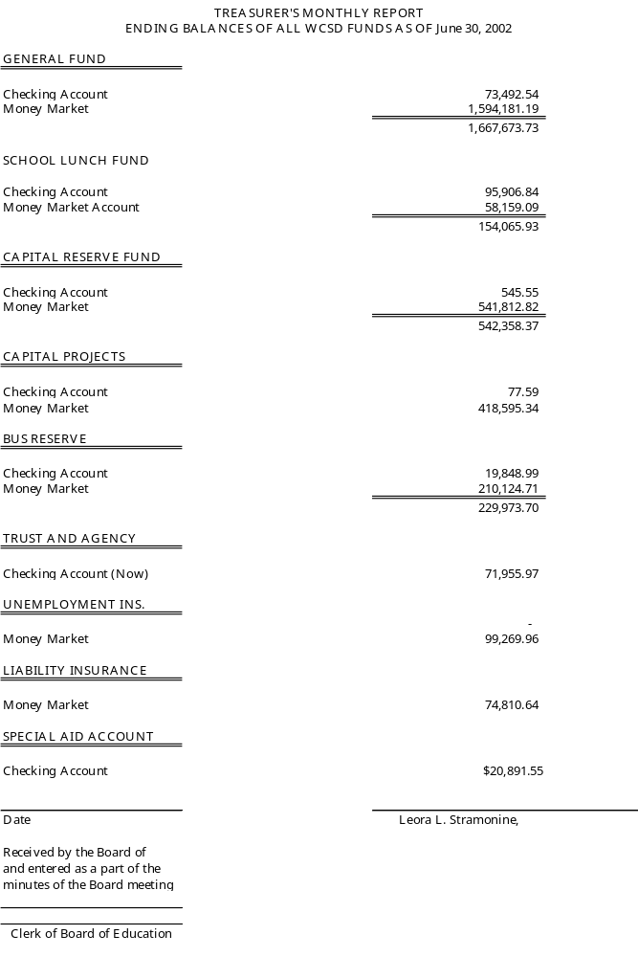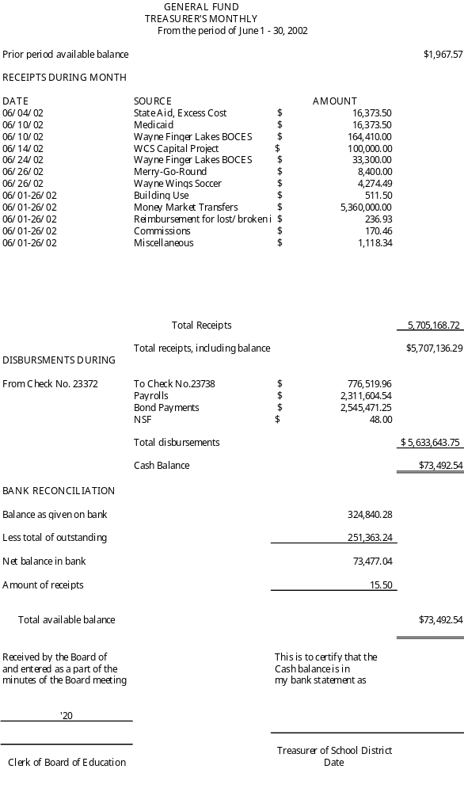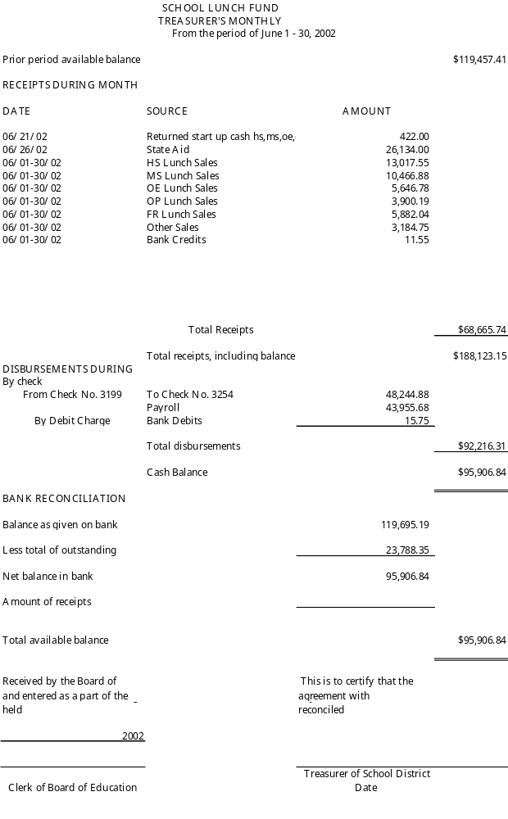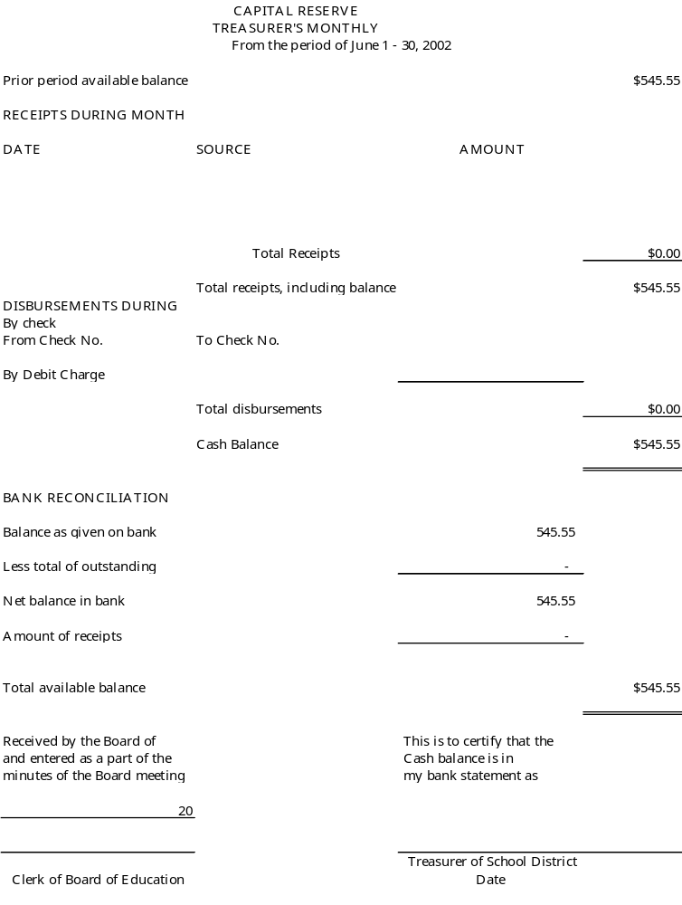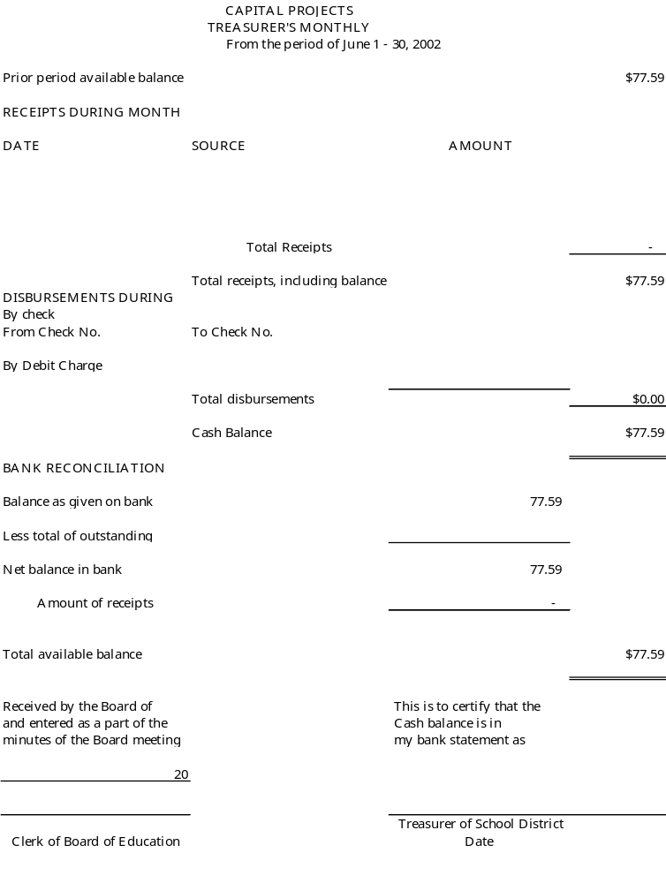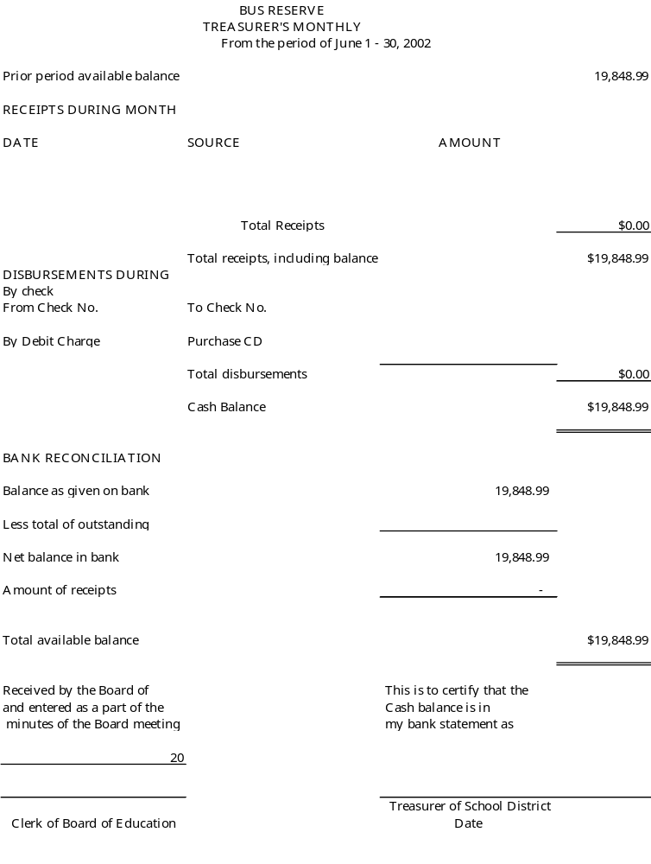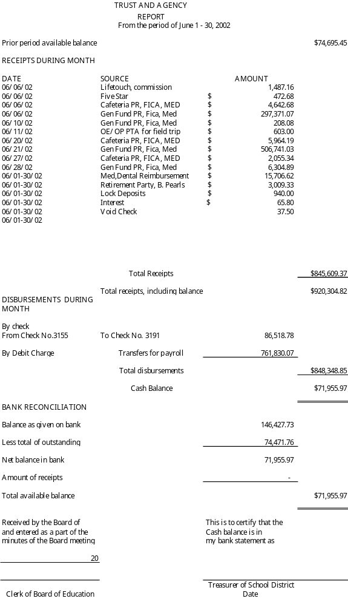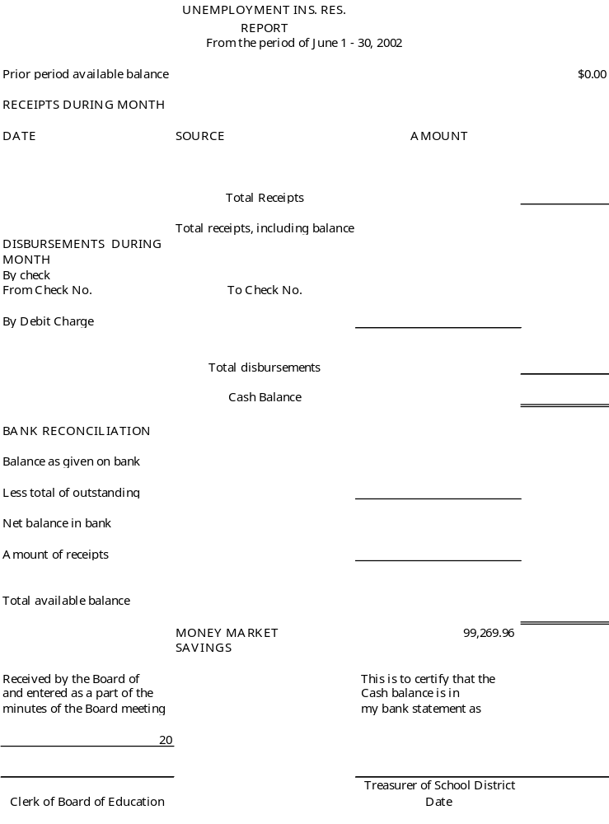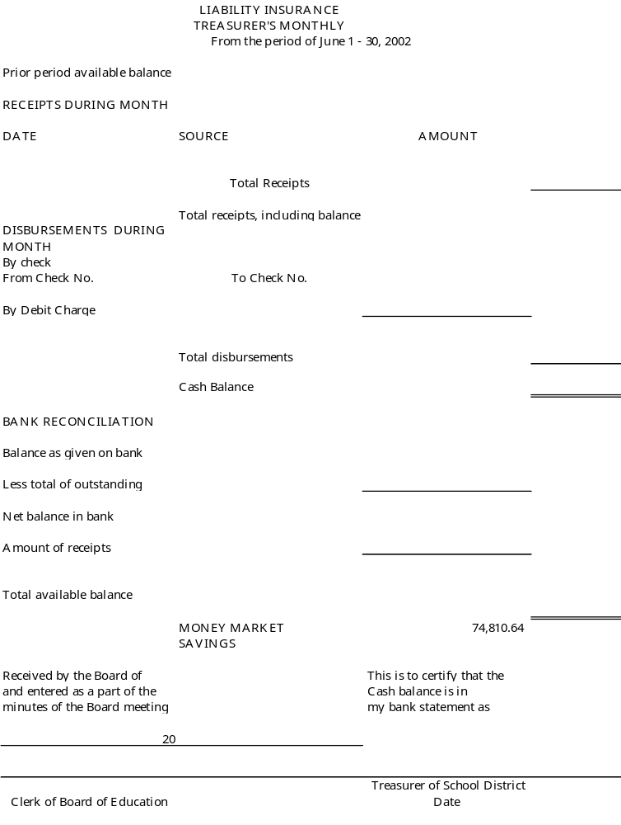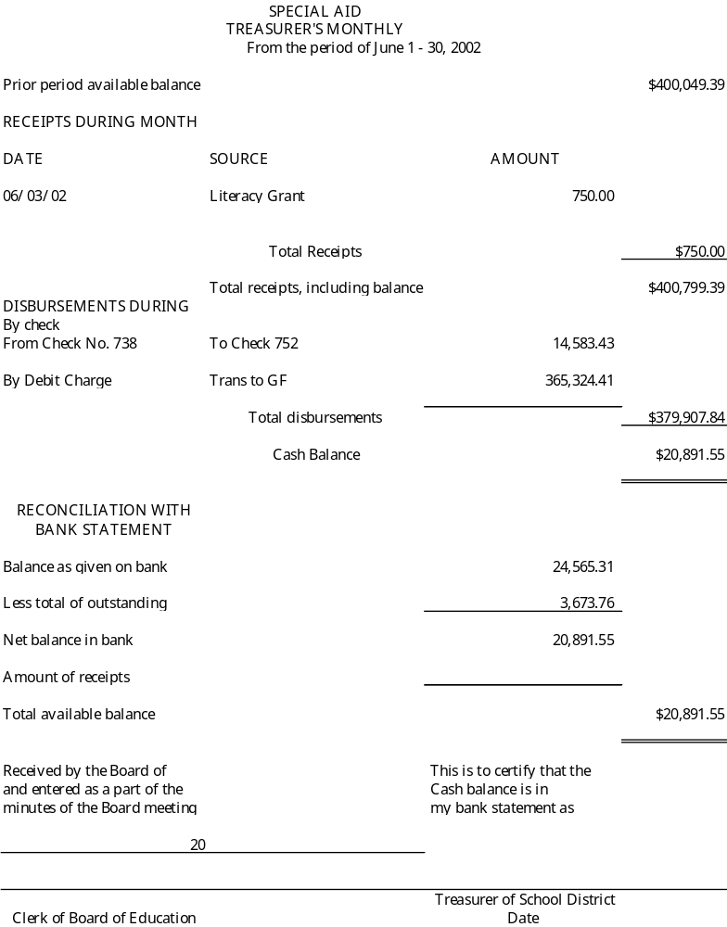
Treasurers

TO: Michael Havens
Superintendent of Schools
FROM: Gregory J. Atseff
Assistant Superintendent for Business
DATE: September 11, 2002
RE: Budget Transfers

In accordance with Policy #6150, please present the attached list of budget transfers to the Board of Education for their approval at their meeting on September 11, 2002.

GJA/db

Attachment

2

TO: Michael Havens
Superintendent of Schools
FROM: Gregory J. Atseff
Assistant Superintendent for Business
DATE: September 11, 2002
RE: Gifts to the District

Recommend that the Board of Education, at their meeting to be held on September 11, 2002, accept the following gifts to the district:

- Various books and tapes from Catherine Contino valued $3, 805.00 to be used in the Team B area of Freewill Elementary School.
- A Mimeo Digital Meeting Assistant valued at $500 and a set of Pasco sensors valued at $484.00 from Greg Switzer.
- A Tektronix Phaser 850 color printer valued at $1,700.00 from Chris Bolton of Ontario, NY.

/db

c: Lee Stramonine
Helen Jensen
Kim Saxby, Freewill Elementary School Principal
Kathleen Green, Technology Coordinator

To: Michael Havens, Superintendent of Schools

Fr: Gregory Atseff, Assistant Superintendent for Business

Date: September 6, 2002

Re: School Lunch Prices

Currently the cost for a school lunch for our students is $1.60. It is my recommendation for the 2002/2003 school year, that the price remain $1.60.

The school lunch program generated a profit of approximately $9600 for the 2001/2002 school year. The program was able to generate this profit, despite the fact that it was a year in which the district paid retro-active pay for the settlement of the CSEA contract.

At this time, we are estimating the fund balance at year-end in the school lunch fund will be approximately $74,000. We have a quality school lunch program. I feel that we can maintain that same level of quality at the $1.60 lunch cost, while keeping the school lunch fund in good financial shape.

Please let me know if you have any questions, or need additional information.

TO: Michael Havens
Superintendent of Schools
FROM: Gregory J. Atseff
Assistant Superintendent for Business
DATE: September 11, 2002
RE: BOCES Cooperative Bids

Wayne Central School District participates in a cooperative bid with the schools in the Wayne-Finger Lakes BOCES area for Various Commodities and/or Services. I recommend that we accept the recommendation of the Wayne-Finger Lakes BOCES to award the bids to the lowest bidders as stated below.

BREAD & BREAD PRODUCTS

The BOCES Cooperative Bid for Bread and Bread Products has been awarded to Interstate Brands Corporation, 313 Fougeron St., Buffalo, NY 14212, for the period August 1, 2002 to July 31, 2003. Interstate Brands did not bid on all items and it may be necessary to purchase some items from other vendors. The bid coordinators suggested DiPaolo Baking Co., Inc. in Rochester and/or Restivo’s Bakery in Clyde as possible sources for non-bid items.

MEAT, MEAT PRODUCTS, CHEESE & FROZEN FOODS AND CANNED AND PACKAGED FOODS

The BOCES Cooperative Bid for Meat, Meat Products, Cheese & Frozen Foods and Canned and Packaged Foods for the 2002-2003 school year has been awarded to Davis Bros., Inc., 4521 County Route 4, Oswego, NY 13126, Palmer Distributing Co., 100 Hoffman Street, Newark, NY 14513, and to SYSCO Food Service, Rt. 173N, Warners, NY 13164

/db

TO: Michael Havens
Superintendent of Schools
FROM: Gregory J. Atseff
Assistant Superintendent for Business
DATE: September 11, 2002
RE: Computer Supplies

In accordance with Section 103A, Article 5-A, of the New York State General Municipal Law, a legal notice was advertised in the official school newspapers inviting the submission of sealed bids for Computer Supplies.

Sealed bids were received and opened publicly on Tuesday, August 20, 2002, at 1:00 p.m. at the district administrative offices.

Bids were advertised to be evaluated on either an item-by-item basis or total basis, whichever best suited the district. Prices submitted are to be f.o.b.

The lowest responsible bidders are identified as follows:

Vendor Bid Award
 | Best Computer Supplies  895 East Patriot Blvd.  Reno, NV 89511 | $ 358.48
 | IANUZI  6018 Corporate Dr.  E. Syracuse, NY 13057 | 8,983.42
 | The Tree House, Inc.  PO Box 590111  Newton Center, MA 02459 | 6,262.85
 | SDF Professional Computer, Inc.  813 South Evanstreet  Greenville, Nc 27834-3267 | 467.00
 | Multiwave  17901 E. Ajax Circle  City of Industry, CA 91748 | 585.00
 | Sentry Business Products  3910 Niagara Falls Blvd.  North Tonawanda, NY 14120 | 1,846.99
 | Total | $18,503.74

/db

COMPUTER SUPPLY BID
August 20, 2002

Best Computer Supplies
Ms. Sandy Bishop
895 East Patriot Blvd., 110
Reno, NV 89511

CDW-G
Mr. Kevin Korn
200 N. Milwaukee Ave.
Vernon Hills, IL 60061

Colonial Business Systems
Mr. David Conklin
101 Lincoln Parkway
East Rochester, NY 14445-1449

Corbi Technology Products
Mr. Matt Marino
1595 Elmwood Avenue
Rochester, NY 14620

Dartek Computer Supply Corp.
Mr. Rich Pearl
PO BOX 4135
Naperville, IL 60540

Educational Resources
Bids & Quotes Department
1550 Executive Drive
Elgin, IL 60123

GOV Connection
Mr. Josh Robinson
706 Milford Rd.
Maramack, NH 03054

IANUZI
Mr. Steven Ianuzi
6018 Corporate Dr.
E. Syracuse, NY 13057

JP Computer Products
Ms. Jeannette Lodice
7724 Victor-Mendon Rd.
Victor, NY 14564

Manchester/LTG
Mr. Bill Waite
106 Dispatch Drive
East Rochester, NY 14445-1448

Meridian Technology Group
Ms. Anne Johnson
6280 Victor-Manchester Rd.
Victor, NY 14664-1406

MGM Consulting
Mr. Sean McQuillan
242 Long Acre Dr.
Rochester, NY 14621

Multiwave
Ms. Jolene Tu
17901 E. Ajax Circle
City of Industry, CA 91748

Rhinotek
Ms. Dawn Cichon
2301 East Delamo Blvd
Carson, CA 90220

SDF Professional Computer, Inc.
813 South Evans Street
Greenville, NC 27834-3267

Sentry Business Products
3910 Niagara Falls Blvd.
North Tonawanda, NY 14120

Soho Imaging
Attn: Scott
911 Thaxted Circle
Webster, NY 14580

Standard Register
Mr. Sean Maloney
140 Allens Creek Rd.
Rochester, NY 14618-3391

Staples Business Advantage
Mr. Thomas Masten
125 Mushroom Blvd,
PO Box 23500
Rochester, NY 14623
The Tree House, Inc.
PO Box 590111
Newton Center, MA 02459

Upstate Computer Corp.
4 Schunnemunk Rd. #302
Monroe, NY 10950

Valiant I.M.C.
55 Ruta Ct., PO Box 3171
S. Hackensack, NJ 07606

XPEDX
Mr. Thomas Kolb.
PO Box 20403
Rochester, NY 14602

